A000-Mali-Dogon-Crocodile-Mask-Wood-19th c

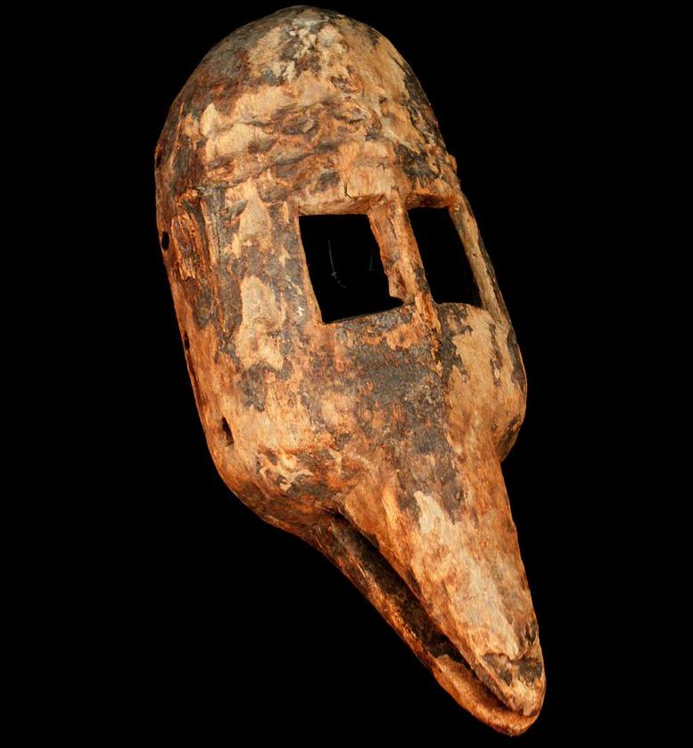

The mythic Dogon crocodile as Nommo

**Case no.:**

**Accession Number:**

**Formal Label:**

**Display Description:**

**Nommos** are [ancestral spirits](https://en.wikipedia.org/wiki/Veneration_of_the_dead) (sometimes referred to as deities) worshipped by the [Dogon people](https://en.wikipedia.org/wiki/Dogon_people) of [Mali](https://en.wikipedia.org/wiki/Mali). The word Nommos is derived from a Dogon word meaning "to make one drink." The Nommos are usually described as amphibious, [hermaphroditic](https://en.wikipedia.org/wiki/Hermaphrodite), fish-like creatures. Folk art depictions of the Nommos show creatures with humanoid upper torsos, legs/feet, and a fish-like lower torso and tail. The Nommos are also referred to as “Masters of the Water”, “the Monitors”, and "the Teachers”. Nommo can be a proper name of an individual, or can refer to the group of spirits as a whole.

Nommo was the first living creature created by the sky god [Amma](https://en.wikipedia.org/w/index.php?title=Amma_(god)&action=edit&redlink=1). Shortly after his creation, Nommo underwent a transformation and multiplied into four pairs of twins. One of the twins rebelled against the universal order created by Amma. To restore order to his creation, Amma sacrificed another of the Nommo progeny, whose body was dismembered and scattered throughout the universe.[[1]](https://en.wikipedia.org/wiki/Nommo#cite_note-1) This dispersal of body parts is seen by the Dogon as the source for the proliferation of Binu shrines throughout the Dogons’ traditional territory; wherever a body part fell, a shrine was erected.

**LC Classification:**

**Date or Time Horizon:**

**Geographical Area:**

**Map:**

**GPS coordinates:**

**Cultural Affiliation:**

**Media:**

**Dimensions:**

**Weight:**

**Condition:**

**Provenance:**

**Discussion:**

**References:**

